**Amazon DynamoDB On-Demand**

Flexible billing option and can serveTD thousand of request per second without capacity planning.

Pay per request pricing model.

Use Case : Spiky, unpredictable workloads.

Dynamically adjusts by predicting the workload.

You can change provisioned to on-demand planning per table once per day.

From on-demand to provisioned can be planned as many times as you want.

**Amazon DynamoDB Auto Scaling**

Automatically adjusts read and write throughput capacity in response to dynamically changing request volumes without any downtime.

You need to specify throughout target, minimum and maximum limits.

Use Case: General scaling, good solution for most workloads.

Works with Cloudwatch to continuously monitor actual throughput optimization. Automatically adjusts capacity up or down depending on the request.

No additional cost associated.

Works with auto scaling.

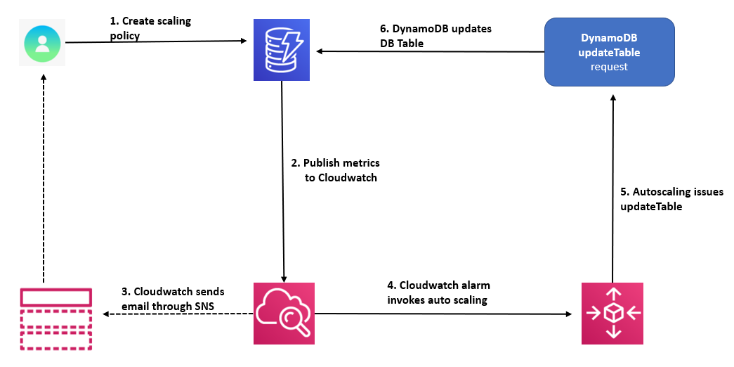

**DynamoDB Adaptive Capacity**

Read capacity Unit is called RCU and write capacity unit is called WCU. When data access is imbalanced one partition can receive higher volume of read or write traffic compared to other partitions.

This partition is called **hot partition.**

**Adaptive Capacity** increases throughput capacity for partitions that receive more traffic. Adaptive capacity is enabled automatically for DynamoDB.

Although traffic cannot exceed the table’s throughput capacity or the partitions maximum capacity.

Partition key portion of the tables primary key denotes the logical partition where data is stored. Provisioned I/O capacity of a table is evenly distributed among the table’s partitions. So, a partition key design that doesn’t distribute I/O request evenly across the partitions results in hot partition that results in throttling.

Optimal use of provisioned throughput of a table depends on the workload pattern, individual item and design of partition key.